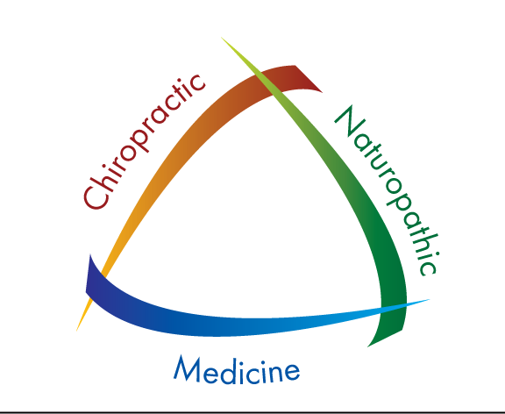
Kurt A. Bailey DC, ND, NP-C Integrative Health & Wellness
Justin Keller DC, MS Lewiston Family Chiropractic
Jolene Ross LMP 3510 12th Street
Kasey Landrus, RN Lewiston, ID 83501

208.799.3333 Phn 208.799.3375 Fx

One Treatment every month for 12 months
Keravive $300 Includes take-home spray Kasey
Keravive $300 Includes take-home spray Kasey
Platelet Rich Plasma (PRP) $750 Dr. Bailey/ Kasey
Keravive $300 Includes take-home spray Kasey
Cellustrious $600 Includes take-home Kit Dr. Bailey
Platelet Rich Plasma (PRP) $750 Dr. Bailey/ Kasey
Cellustrious $600 Dr. Bailey
Platelet Rich Plasma (PRP) $750 Dr. Bailey/ Kasey
Cellustrious $600 Dr. Bailey

Office Visit, Consultation, Evaluation and Review at 12 months

Total Cost: $4950 = 9-12 months of treatment

